WHEELCHAIR-MOUNTED DOG
TREAT DISPENSER
PROPOSAL

Team Members  Zainab Abdullahi  Gage Moore  Jachan Shrestha  Robby Wignall  Adam Dost – Project Manager | Faculty Supervisor  Dr. Nathalia Peixoto  Client  Service Dogs of Virginia
Table of Contents

Executive Summary 2
Problem Statement 3
Need for Redesign/Prior Art Analysis 5
Approach 7
Problem Analysis 7
Approach 9
Dispensing Mechanism Design 1A (Conceptual Team Model) 10
Dispensing Mechanism Design 2A (Conceptual Team Model) 11
Dispensing Mechanism Design 1B (Conceptual Team Model) 12
Dispensing Mechanism Design 2B (Conceptual Team Model) 13
Introduction to background knowledge/phenomenology supporting the project 13
Treat Dispenser Project Requirements 16
Preliminary Design 18
Functional Architecture 28
Level 0: 28
Level 1: 28
Level 2: 29
System Architecture 31
Circuit Design 31
Circuit Waveform 32
Power Requirements 33
Preliminary Experimentation Plan 34
Preliminary Project Plan 36
Proposed Schedule: 37
Potential Problems 38
References 45

Executive Summary

Currently, 15% of the world’s population suffers from some sort of disability. Of that 15%, 4% suffer from an advanced disability such as cerebral palsy and multiple sclerosis [1]. Many of the people who suffer from such diseases are wheelchair bound and use a service dog in order to assist them in their daily lives.
While their service dogs are fully trained upon reception, the dogs must go through yearly tests in order for them to keep their certifications up to date [2]. To keep the dogs well trained, they must be constantly exposed to the training conditions to help them remember their “tricks.” Due to the high cost involved with training the service dogs, most owners would prefer to train the dogs themselves, which normally involves some sort of reward for the dog (e.g. a treat). This presents a problem for people suffering from disabilities; they are not able to complete certain tasks easily such as rewarding their dog because of their disability.
This project intends to correct this problem by developing a treat dispenser that will work with a variety of wheelchairs and will comprise of a universal input for plethora of input devices to activate the treat dispenser, such as a switch or a button. The treat dispenser will also be small enough so the wheelchair in which it is mounted on can fit through doors and will not impede the functionality of the wheelchair. A highlight of this project will be the ability to recreate the dog treat dispenser from relatively household items. This will allow the treat dispenser to be cheap and will be able to serve a multitude of people in ne

Problem Statement

The wheelchair is one of the most commonly used assistive devices for increasing and enhancing personal mobility, which is a necessity for being an independent and productive member of society. There are many conditions and afflictions which may result in the need of a wheelchair such as multiple sclerosis, cerebral palsy and muscular dystrophies. Disabled individuals who are wheelchair bound and accompanied by service dogs account for .9 percent of the U.S. population [1]. These highly trained canines can provide independence to their owners and significantly enhance their quality of life. These dogs can complete a wide range of tasks from opening doors, retrieving dropped items and pushing their partners up ramps. These dogs are an integral part of these individuals’ lives and must go through extensive training to earn this role [3]. In order to achieve maximum performance from these dogs, frequent rewards in the form of verbal affirmations and treats are required. Rewarding the dog is essential. It not only increases the emotional relationship between the dog and the owner but most importantly, provides the dog with much needed positive reinforcement.
This project was undertaken at the request of The Service Dogs of Virginia, a non-profit organization that raises, trains, and places dogs to assist people with disabilities due to the failure of several designs that have attempted to ameliorate the burden to create an effective standard of assistance. The main challenge users who have limited or no hand mobility at all is giving the dog a treat. There have been several great ideas and attempts to create an adaptive treat dispenser that could be integrated seamlessly to a wheelchair, but there are none that are commercially available as of today nor patented for this use. Despite the numerous attempts made to make this merchandise commercially accessible to the public it has failed repeatedly due to design limitations such as; the dispenser being too large to be seamlessly embed into a wheelchair as well as there being malfunctions with getting the dispenser to release the desired number of treats appropriately. While there have been few designs that have overcome these setbacks, they too have proven to be futile as a result of the dispenser bowl being too small, and fiscal challenges due to the expenses of printing and dipping into a food safe coating.

Need for Redesign/Prior Art Analysis
Currently, there is a need for an improved dog treat dispenser. The available prior art is limited by several factors such as being bulky, cumbersome, mechanical, non-food safe, and not adaptable to a wheelchair. Many handicapped people suffering from advanced disabilities do not have the dexterity as people without disabilities do. This leads to a need for a new design in order to meet their needs.
For example, one of the closest designs currently available is a 3D printed wheelchair treat dispenser [4]. This design is based off a mechanical design in which the user will move a lever in order to activate the dispensing of a treat. As previously mentioned, while this design would be suitable for a person that can actuate a lever, many who suffer from advanced disabilities such as cerebral palsy is unable to do this. The need for an electronic button would be more suitable for such a person who may only be able to move their head in a certain direction or lacks the coordination of their appendages.
Another example would be an “Animal and Food Treat Dispenser” [5]. This design lacks the ability to adapt to a wheelchair as it is cumbersome, has a very small rotational wheel in order to dispense a treat, and can only use a rectangular style treat. There exists a plurality of problems with this design that would not be suitable for a person with an advanced disability. Furthermore, “Treat Dispenser,” “Dog food Dispenser,” “Automatic Feeding Device,” “Pet Feeder for a Handicapped Pet Owner,” and “Dispensing Machine” all share the common characteristic of being too large to fit on a wheelchair, as well as having the inability to dispense a treat electronically [6-10].
The need for a generic switch to activate the dispensing of a treat is clearly needed for people with advance disabilities as they will be able to use a switch, button, or other form of activator that they already utilize in everyday life to complete tasks. In addition to the proposed design to have a generic switch input, it will also be electronically controlled to remove the need for a mechanical input to dispense a treat. This will allow people with advanced disabilities to train their dog in order to comply with the testing requirements to keep their dog “in service.”
Upon reading the available prior art, there is no indication that our proposed design will infringe on any of the prior art. While there exist a few key elements such as a rotational food compartment, a tray portion, and a button, none of the elements in combination with our design would infringe on existing patents [11-13]. As all the designs lack the use of a circuit and/or microcontroller to activate the dispensing of a treat coupled with an adaptable size food storage area that is mountable to a wheelchair. Thus, based on our review there exists novelty within our design.

Approach
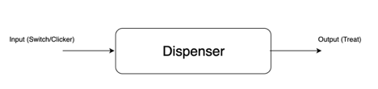
Figure 1: Basic Design with Input and Output

Problem Analysis
The customer has demonstrated earlier versions of the automatic treat dispenser and discussed the flaws of those previous designs. In an attempt to overcome all these issues with previous designs, the following will be considered.
- Design being too big
Almost all the doors in households or public places in the U.S. pass the bare minimum requirement for Americans with Disabilities Acts (ADA) which means wheelchairs narrowly manage to pass by. With the previous design being too big, the mobility of the wheelchairs was limited, which dissuaded the users to install the dispenser.
Customer suggested design to be mounted on the side or back of the wheelchair with long enough tubes to allow the treats to be dispensed where needed. This will allow the width of the wheelchair to not be modified.
- Hard to reproduce
Customer requested the design to be easy to reproduce, which means finding the parts and assembling the device must be easy to ordinary person with very few to no engineering skills. All the previous designs used microcontrollers (especially Arduinos) for controlling the dispenser, which required a certain degree of programming skills to reproduce the design. Some of the designs also relied on the use of 3D printed material for custom parts, but this was found to be too expensive, time consuming, and not to be food safe.
Customer requested the design to be easily reproducible (i.e., people with no programming skills would be able to build the dispenser following simple instructions). The parts for the design should be easily found in the market and food safe for all portions of the design. Faculty Supervisor suggested the use of 555 timer as an alternate to the use of microcontrollers. This would allow the circuitry to be implemented on a simple printed circuit board (PCB) with slots labeled for required components, providing a Lego-type build.
- Difficulty in getting right number of treats to dispense
Customer stated the problem in dispensing a consistent number of treats every time in some of the preliminary designs. The dispenser should never dispense more than 3 treats at a time as this could lead to over-treating the service dog and causing negative behavior from the service dog in time [3].
- Must work for people with disabilities
Our target users of this device are wheelchair bound people who have limited mobility of their body parts such as head, hands, legs or fingers. The design should be simple enough to dispense the treat at the click of a button or flip of a switch of the user’s liking. This will require a universal mono-jack input to the device.
- Durability
The dispenser should be durable and weatherproof. Since a wheelchair provides mobility, the dispenser must handle the vibrations from travel, as well as work in inclement weather. The dispenser should be strong enough to handle knocks from service dogs, people, and getting bumped while the user navigates through narrow areas, which requires strong mounting.
- Material Selection
Customer requested to use food safe materials for the dispenser to avoid any health-related hazard. As mentioned earlier, most of the previous models used 3D printed parts which possess health risks to the service dogs as bacteria can build up in crevices between printed layers. A smooth surface should be used.
- Jamming problem
Customer noted jamming problem with some of the earlier designs. The treats are jammed in the dispenser or the parts of the machine are stuck.

Approach
The automatic treat dispenser will need to consider all the design flaws from previous dispensers in order to provide a working solution to the customer.
- Body
The body of the dispenser shall be compact so as not to obstruct the mobility of the wheelchair. It will be fitted with a universal wheelchair mount to accommodate different sizes of wheelchair. It will be designed to activate as normal in all kinds of weather and shall be sturdy enough to handle the wheelchair vibrations, and bumps. Readily available material will be used for the main body of the unit. The parts that come in contact with the treats will be food friendly (e.g., stainless steel).
- Input
The input to the dispenser will be a physical touch button with a mono signal. The team shall primarily focus to design a dispenser that dispenses the consistent number of treat every time on a single click on the button. It shall be designed with self unjamming mechanism to avoid treats getting stuck by using some type of vibrator. The team shall also work on different input/activation method for the dispenser like RC signals, accelerometer.
- Output
The dispenser should output the click sound used for service dog training as well as the dispensed treats to the holding tray mounted on the wheelchair. The reason for adding the click sound is to attract the service dog and ensure that they can use the device appropriately. It also provides a verbal cue to the user that the dispenser activated correctly.

Dispensing Mechanism Design 1A (Conceptual Team Model)
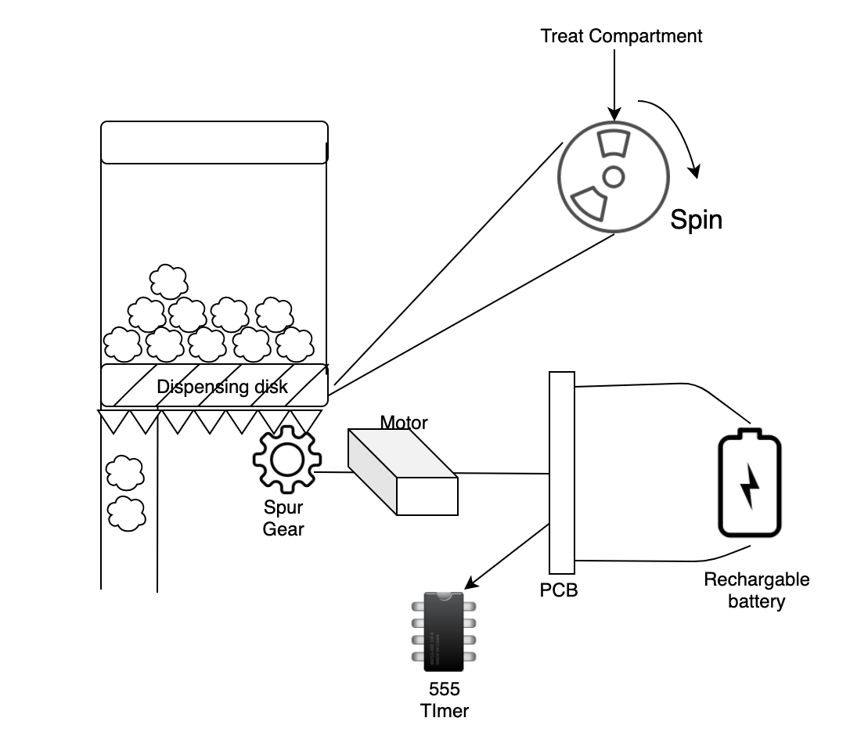

Dispensing Mechanism Design 2A (Conceptual Team Model)
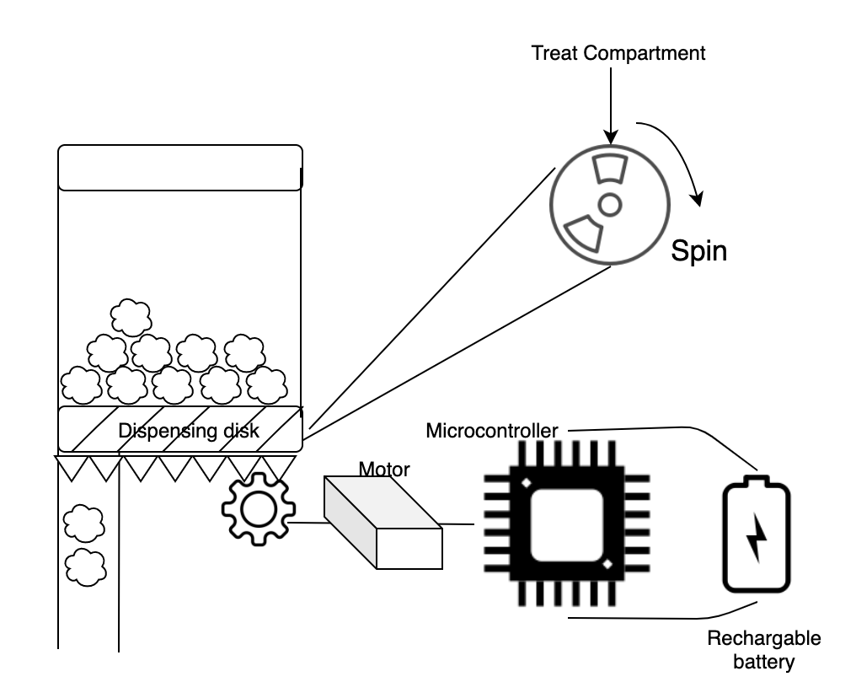

This design has a dispensing disk fitted at the end of a pipe. The dispensing disk is designed with gear teeth on the edges for the rotation of the disk. The rotation of the disk is controlled by the spur gear fitted right next to the disk. One rotation of the spur gear dispenses 2-3 treats at a time. Spur gear is powered by either a dc motor or a servo.

Dispensing Mechanism Design 1B (Conceptual Team Model)
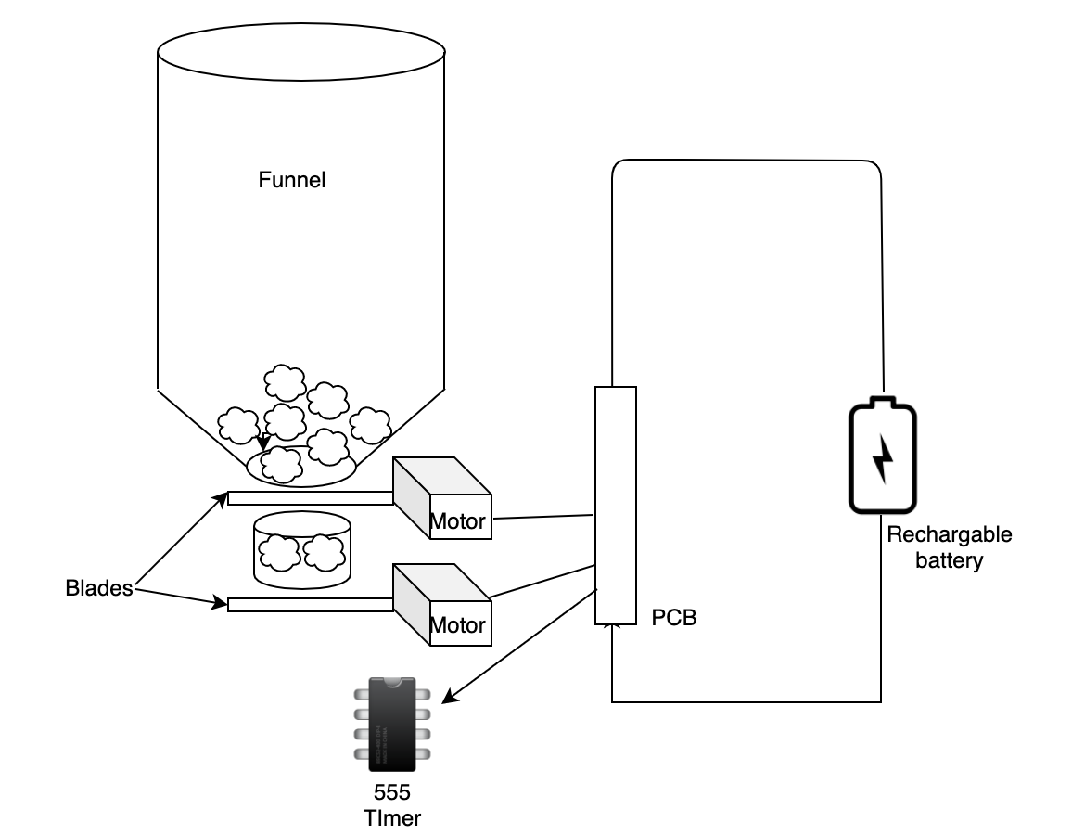

Dispensing Mechanism Design 2B (Conceptual Team Model)
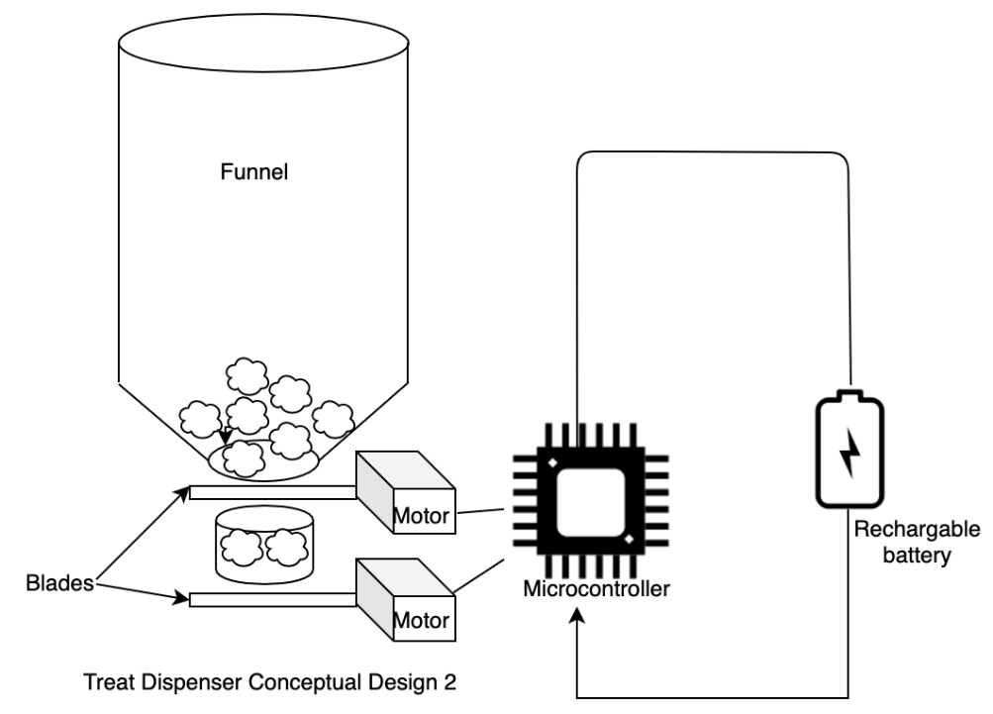

In our alternate design, the dispenser has a funnel that holds the treats to be dispensed. Dispensing will be controlled by two blades fitted right beneath the funnel and the treat measurement pipe. The motors that move the blades are fetched instructions from PCB board which takes input from the user and is powered by a rechargeable battery.

Introduction to background knowledge/phenomenology supporting the project
This project will require a considerable amount of time and effort from all the members of the team. Our team has created the conceptual designs that will satisfy all the requirements of the project. Next step is researching on the parts that will be used together for building the design. Our goal is to find the parts that can be easily found on the market and bring it together to build the design. Moving on, the project will require the circuit building skills of the team. Our team will work closely in building the circuit and designing PCB for the project. To keep the simplicity in the design, our team shall restrict the use of microcontroller and use 555 timer or other forms of controllers. After the PCB is manufactured and the parts are decided, the project group will work on housing the parts and finally mounting the device to the wheelchair.

Product Testing
Once two of the most promising designs are complete, the treat dispensers will be tested thoroughly in a lab to ensure that it works as needed. Once confidence is put into the designs, they will be tested by multiple wheelchair bound individuals and their service dogs to measure the devices’ performance, quality and safety standards. The device will be tested to verify the requirements of the specifications. The device shall be tested to determine if it solves the current problems faced by the customer. The device will also be tested to identify any potential cost savings for the production. The team will then work on to troubleshoot any problems encountered or modify the designs if required. The team shall keep its eyes on how the device is performing functionally for consistent dispensing.

Microcontroller Design
The motors and switches of the dispenser require some means of control. The controls for Design B will be done through software written for a Raspberry Pi controller, the exact version will be decided on later. The Raspberry Pi will control the user interface, the motors, the number of treats dispensed and accurate dispensing through a distance sensor. An embedded system, such as the Raspberry Pi will allow greater variation in the setup and usage of the input/output mechanisms and the changes the user makes to the standard operation. The programming “pseudocode” of the Pi can be broken down into a flowchart. The system accepts the users input through a click of a button or movement of the head. The system will then check if there are treats to be dispensed in the funnel. If the funnel is empty the system will alert the user by the blink of an LED (preferably red). If there are treats, the system will output a “click” sound and the treats will be dispensed. Additionally, the user will have the option to choose the number of treats dispensed. MC1 below demonstrates how the Microcontroller is expected to behave in the dispenser.

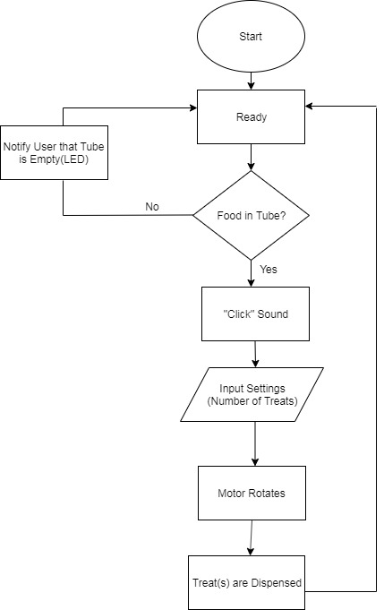
MC 1

Treat Dispenser Project Requirements

Mission Requirements:
The device shall assist people with disabilities in wheelchairs by providing them a method to treat their service dogs.

Functional Requirements:
- The device will hold up to at least a cup of treats at a time to provide rewards for the service animal throughout a day’s time.

- The device shall use an accelerometer-based control input so that someone with limited physical abilities will still be able to operate the dispenser.

Operational Requirements:
- The device will operate while mounted on a wheelchair.
- The device shall be vertically fitted onto the wheelchair to ensure that the device can operate properly, and the owner of the wheelchair can still fit through the same spaces.

- The device will dispense varying number of treats depending on the operators input.
- The device shall have a self-healing method of unjamming itself to ensure that it can dispense food without much assistance from the owner or other party.

6. The device must be easy to clean
Input / Output Requirements
- The device will accept input from the operator. The physical input device will vary, however, the interface with the primary device will be consistent no matter what.

- The device will accept dog treats into a storage container inside the device.

- The device will output dog treats through a pipe system that will deliver the food to a food tray.

Technology:
1. Shall use some electrical timers
2. Shall use some form of pipe to move food from storage to destination.
3. Shall use some form of circuit coating or hardening to ensure durability.

Preliminary Design
The automatic dog treat dispenser must implement a design that is robust while being sleek and lightweight. Since the treat dispenser is installed on a wheelchair, it cannot interfere with the normal operations of the wheelchair, nor limit locations that the user can go in the wheelchair. It must be low profile and able to mount anywhere with adjustable tubes to accommodate a low or a high mounting of the device. The device will need to be rechargeable battery powered to work autonomously from the rest of the wheelchair. It cannot be responsible for draining the wheelchair’s power as there are more important functions of a wheelchair than a dog treat dispenser.
The dog treat dispenser should integrate seamlessly with the end user’s switches/buttons using a 3.5mm mono-jack as connection. This connection will simply need to close a circuit to trigger the dispenser when activated and remain open otherwise. The project will also include the creation of a switch using accelerometers or some other method (perhaps using fiber and detecting vibrations due to movement). This portion is still to be discussed and can be further investigated once the main treat dispenser has been completed.
There are four main areas for the automatic treat dispenser: the dog treat storage compartment, the treat staging and dispensing area, the circuitry and mechanism to activate the treat dispenser, and the treat deployment tube.
Treat Staging and Dispensing Area:
The treat staging and dispensing area influences what the mechanism to activate the treat dispenser should be, as well as the dog treat storage compartment. The dog treat storage compartment feeds directly into the dog treat staging and dispensing area, and the circuit has to work for whatever mechanism is established, so the design must start here. There are three styles of dispensers to be evaluated: gumball machine style, Ferris-wheel style, and stopper style.
1) The gumball machine style consists of a horizontal, circular plate that spins on the axis perpendicular to its center with cut outs to drop the treats through a hole when they are to be dispensed. This plate would have three to four openings around the outside that are just large enough to hold two to three treats side-by-side.
This spinning plate would then sit on top of another plate that has only one hole in it the same shape as the openings in the spinning plate. This plate would be static and should be able to line up with one of the openings in the spinning plate at a time. There would then be one more plate above the spinning plate with an opening that is large enough to let treats filter into one or two of the openings on the spinning plate at a time. The opening would have to be offset from the opening of the bottom plate and towards the start of the rotation after the bottom opening.
These three circular plates would be at the bottom of the dog treat storage compartment so that all the treats sit on top of them and can be filtered in as the spinning plate is activated.
The spinning plate should turn 1/3 or 1/4 of a full spin at a time (depending on how many openings) and have an opening line up with the opening in the bottom plate each turn.
Thus, the treats are loaded into the spinning plate one or two openings at a time and then dispensed one opening at a time for each activation. The number of openings will have to be tested to determine what works the best and provides the most consistent results.
2) The Ferris-wheel style consists of a design similar to the gumball machine style, but the mechanism spins vertically instead of horizontally. With this design, only one plate is required. Around the outside perimeter should be pockets/compartments large enough to hold the two to three treats needed at a time. These compartments would have openings that face outward from the center axis of this spinning wheel.
The wheel with compartments around the perimeter would sit inside a round cover that is just large enough to allow the wheel to turn within it. This cover is to keep the treats inside the compartments as the wheel turns. The cover would have one opening at the top and the bottom that are the same size and would line up with the compartments on the wheel.
Again, this wheel would sit below the dog treat storage compartment and treats would filter in one compartment at a time. As the wheel turns, treats are dispensed at the bottom of the wheel one compartment at a time.
This wheel would have four compartments around it so that at any time, one compartment is being loaded with treats, one is loaded with treats and waiting to be dispensed, one is being dispensed, and the other is empty. This way, the wheel only has to make quarter turns each time. Half turns could require too much effort and shorten the life of the electronic mechanisms to be used.
3) The stopper style dispenser employs two stoppers: one to help stage the treats, and one to dispense the treats. The dog treat dispenser should dispense quickly, so the treats should be ready to go when activated. Thus, with this style, there should be one activation when first used where the dispenser is loaded, and no treats are dispensed.
There would be a space between the two stoppers that is enough to store and stage the two to three treats that need to be dispensed. To keep the dispenser’s size as small as possible, it makes sense to have the treats staged vertically between the two stoppers. Thus, there should be a tube between the two stoppers slightly larger than the diameter of a dog treat.
When the automatic dog treat dispenser is activated, the bottom stopper is removed from the tube first, allowing the treats that are staged to drop and be dispensed. This should open long enough to allow up to three treats to drop and then close shortly after that. Once the bottom stopper is back in place in the tube, the top stopper is removed and treats from the dog treat storage compartment are able to fall into the staging area. This should be removed long enough for three treats to fall in, and then close.
There is a potential hazard with this design in that the top stopper will not be able to go back in place in the tube if a treat falls in the place it should be in. Thus, this top stopper should have a blade on it and be strong enough that it could cut through a treat or break apart a blockage.
The stoppers and tube must all be in an enclosure so that dog treat crumbs do not fall out of the dispenser as the user is wheeling around. There will also be a gasket around the edge of the stoppers to create a seal when in the tubes for the same reason. Unintentionally dispensed crumbs or treats could lead to negative behavior in the service dogs
All of these designs are susceptible to jamming, and dog treats can sometimes get sticky in humid areas, so preventative measures must be taken. These measures can be taken within the dog treat storage compartment.
Dog Treat Storage Compartment:
The storage area for the dog treats needs to work with whichever dispensing method above is chosen. Each will require a slightly different storage compartment to sit above the dispensing mechanism so that treats are fed into the staging area correctly. Each will require the same construction, however.
The storage compartment will have smooth, easy to clean surfaces, and to be detachable for cleaning. The material used will need to be food safe. It should also be transparent or translucent enough for the user to see the amount of dog treats still available at any time. The bulk of the storage compartment can be made of food safe plastic or Tupperware type container. The compartment will be slim and wide to hold at least a cup of dog treats at a time and ensure the wheelchair’s profile is minimally impacted.
All storage compartments should have a funnel type bottom to feed the staging area of each dispensing mechanism with dog treats. Though each style would be slightly different, the overall design is the same. The funnel will have sharp enough slopes, so the treats do not get stuck.
The dog treat storage compartment will also have an internal vibrator that activates when the automatic treat dispenser is activated. This is to help ensure that the treats feed into the staging area and jams are broken free. The vibrator can be attached to the outside of the storage compartment.
There will also be a hinged lid on top of the storage compartment with an easy to use latch/clasp for simple refills. The lid will have a seal to make sure the dog treats do not spill out the top of the compartment.
The dog treat storage compartment will be the largest part of the dispenser so it will also have a flat face with some mounting tabs to make it easy to mount anywhere on a wheelchair. The storage compartment will need to be tightly secured to the dispensing mechanism and the rest of the treat dispenser so that no other mounting points will be needed.
Below is a summary of the materials that were evaluated to act as the storage container for the dog treats. One of the key requirements for this storage container was that it must be safe to store food in and below are the results of our findings.
Materials Report

Materials | Properties | Use in project
3D printed | Cheap depending upon the type of material, color, tolerance and quality used [14]. Strong and can be printed as desired. Used widely in casing and parts. Materials like PLA and ABS are cheap and ranges from $15-$20 per kg, while Nylon and Soft PLA are much more expensive. | Could be used to case the final design of the project. CAD 3D designs can be easily modified before the production.
Plastic | While Plastic casing might sound like 3D printing, there are many companies that produce plastic enclosures for electronic enclosures [15]. Enclosures are cheap ($1-$10) and can be cut or modified to fit the casing needs [16]. Tough and weatherproof. | Could be used to case the final design of the project.
Wood  /Homemade | Commonly used plywood is easily available in the nearest home depots and can be cut into desired shape and size even by people with no skill. | Could be used to case the final design of the project. MDF are cheap and will keep the cost down. PINE could be used to add quality to the project.
Metal (aluminum) | Enclosures are readily found in the market. Ductile, soft and malleable. | Could be used to case the final design of the project.

Motors | Properties | Use in project
Servos | Precise movement, cheap, easily available, different sizes available. Can easily be paired and controlled with Raspberry Pi or MSP430. Operating voltage 4-10v, excellent torque at high speed (130RPM) [17]. | Controlling mechanical movement
Brushed/ Brushless DC motor | Less noisy, easily available with various power options, smooth motion, simple to control. | Controlling mechanical movement
Stepper motor | Slow and precise movement, good torque at low speed, noise, low efficiency [18]. | Controlling mechanical movement

Casing needs to be strong and rigid. While plastic and metal are mostly weatherproof, wood can also be coated to make it waterproof [19]. Readily available plastic and metal enclosures are preferred; however, wood is also a good option to enhance decorations or add quality.

Circuitry and Activation Mechanism:
The circuitry in all three design styles will require the use of a timer circuit. This timer circuit will need to activate a motor for long enough to spin the mechanisms in the first two cases and also work out the timing between the two stoppers in the third case.
The circuitry in the first two cases will require a motor to spin the plate/wheel far enough to dispense the treats. The motor speed will be used to time how long it takes for it to spin the plate/wheel to the correct position and the timer circuit will have to be built accordingly to keep the motor activated for that amount of time [20].
Another method would be to use limit switches that are bypassed when the device is activated and then activated right after so that the device stops when a limit is reached. These can be user adjustable for troubleshooting purposes [21].
In the third case, there will be two motors that need to be timed the same from opening to closing [22]. There will also need to be a timer between the two stoppers so that adequate time is allowed between the treats dispensing and the next set of treats being staged. The timing required between will need to be at least two times the amount of time the bottom stopper takes to operate in order to allow the staged treats to drop before the next treats are staged.
The circuitry will be installed within a sealed container to protect the components from damage. The PCB will be designed so components can be easily replaced and will be mounted on rubber mounts to protect the circuit from vibration damage [23]. All connections will be solid enough for a long life under normal use.
The circuit will have a 3.5mm mono-jack input to activate the circuit (in place of the shown input switch) and will be rechargeable battery operated for autonomous operation. The 3.5 mm mono-jack will be the connection point for the switch of user’s choice. The circuit itself will look at this portion as a simple switch that closes the circuit when the switch is activated. The lower right circuit depicts the activation circuit. When a button/switch is pressed, it will keep the circuit on for a specified period of time (via the time constant of the 1000uF capacitor) and will turn off the circuit when the capacitor is discharged.
The upper right circuit is the circuit that controls the motor speed. As previously mentioned, it will use a 555-timer chip to create a Pulse Width Modulation signal to drive the motor [24], [25], [26], [27]. This will spin the motor/servo in a direction (e.g. clockwise or counterclockwise) in order to actuate the dispensing mechanism.
An accelerometer type switch will also be investigated as a method of activating the treat dispenser. This device would be wireless for easy use and help those individuals that lack any kind of dexterity. A simple nod could be enough to trigger the accelerometer and activate the treat dispenser
The circuit might also include a small speaker that emits the dog training clicker sounded to pique the interest of the service dog.
Dispensing Tube:
The Dispensing Tube would be the simplest part of the dog treat dispenser. It will consist of a tube that allows the dog treats to easily slide through, and a tray attached at the bottom that will catch the treats and provide a constant location for the service dog to go to for the treats. The tray will be constructed of stainless steel or some hard plastic that will last with constant use by the service dog. It will be big enough for a large service dog’s nose to fit in so that it accommodates as many service dogs as possible. The tray will also have provisions for mounting it to a wheelchair, though these mounts will not be responsible for any of the device’s weight. It will simply help to hold the tray in place and ensure the treats are dispensed to the tray.
The dispensing tube will be tightly attached to the bottom of the dispensing mechanism and should be only slightly larger than the opening the treats will be dispensed through. The tube will be flexible so that the storage compartment and dispenser portion can be mounted in a variety of locations and still allow the use of the same tube.

Overall Design:
The overall design consists of a treat storage area connected to the treat staging and dispensing mechanism along with PCB that can be mounted anywhere on the wheelchair, though the higher it can be mounted, the better it should work. There is then a flexible dispensing tube connected to the dispensing mechanism that allows the user to dispense the treats to any position on the wheelchair.
This allows the bulk of the unit to be mounted on the back of the wheelchair where it can be out of sight and not interfere with the user’s ability to get through doors or other tight places. This design should provide the most flexibility and use across many wheelchair types.

Functional Architecture

Level 0:
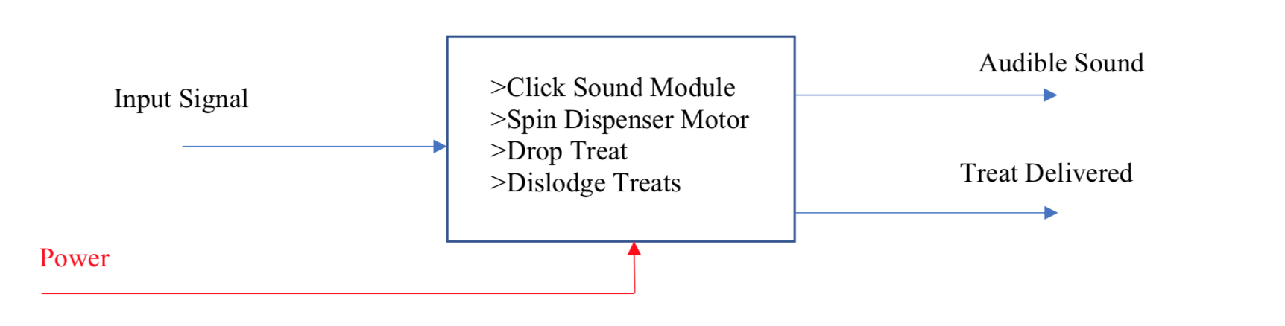

Level 1:
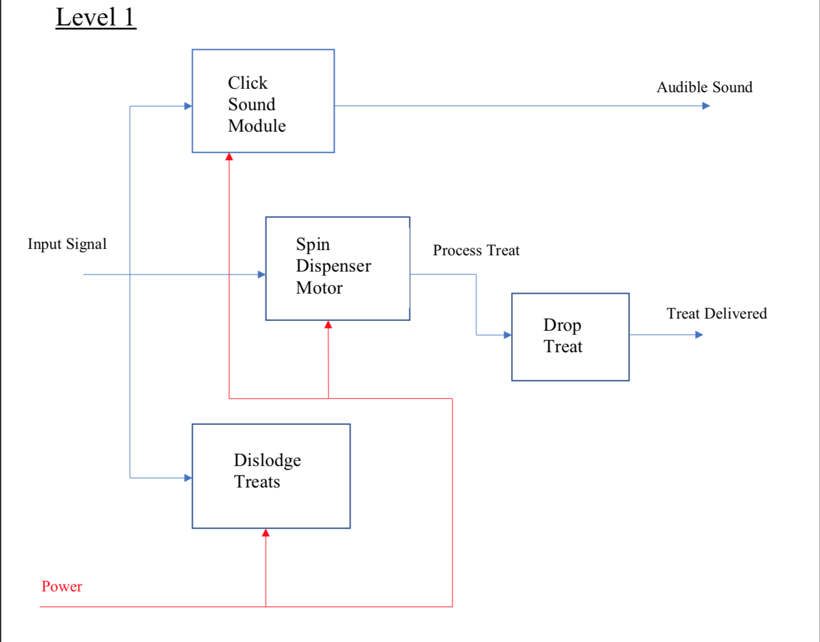

Level 2:

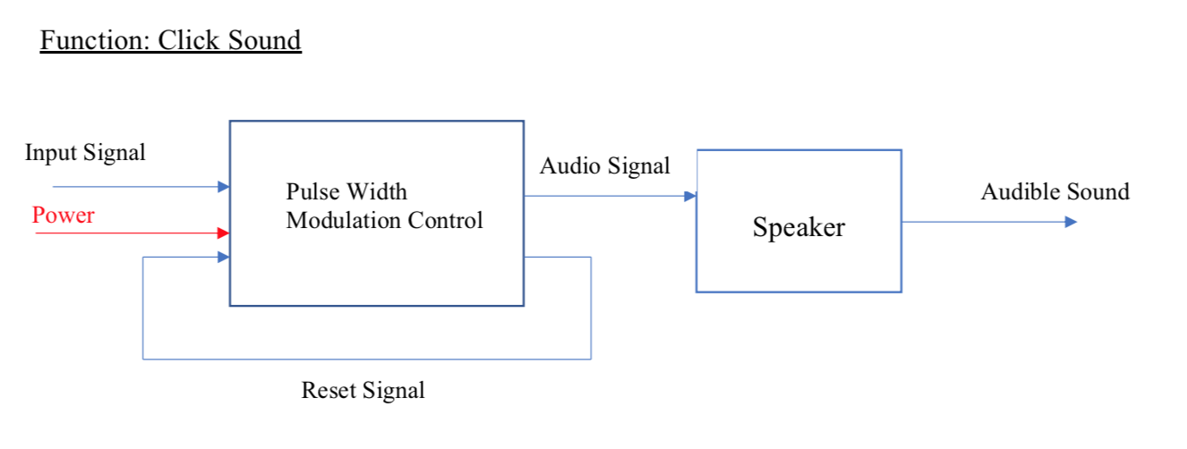
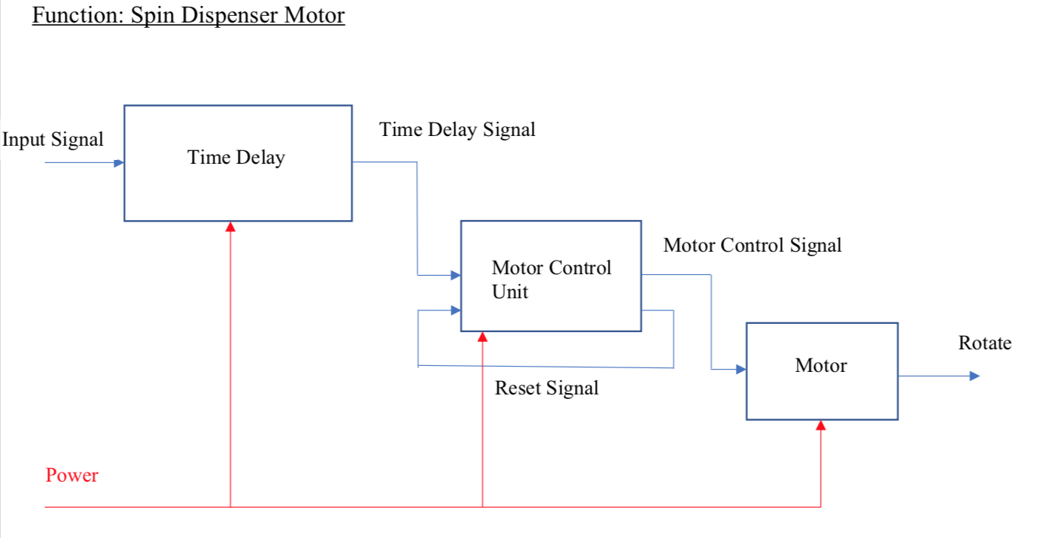

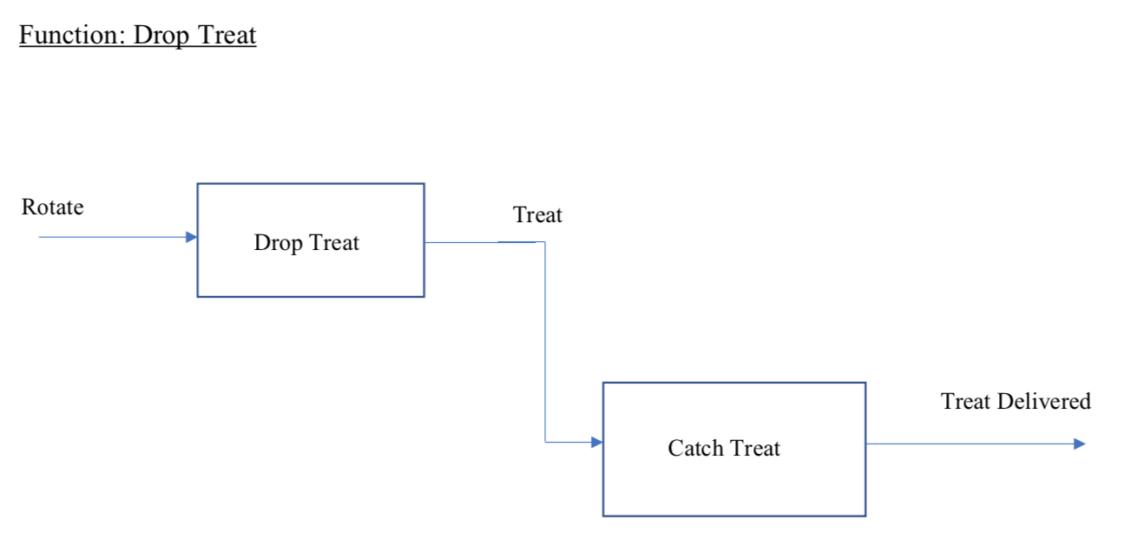
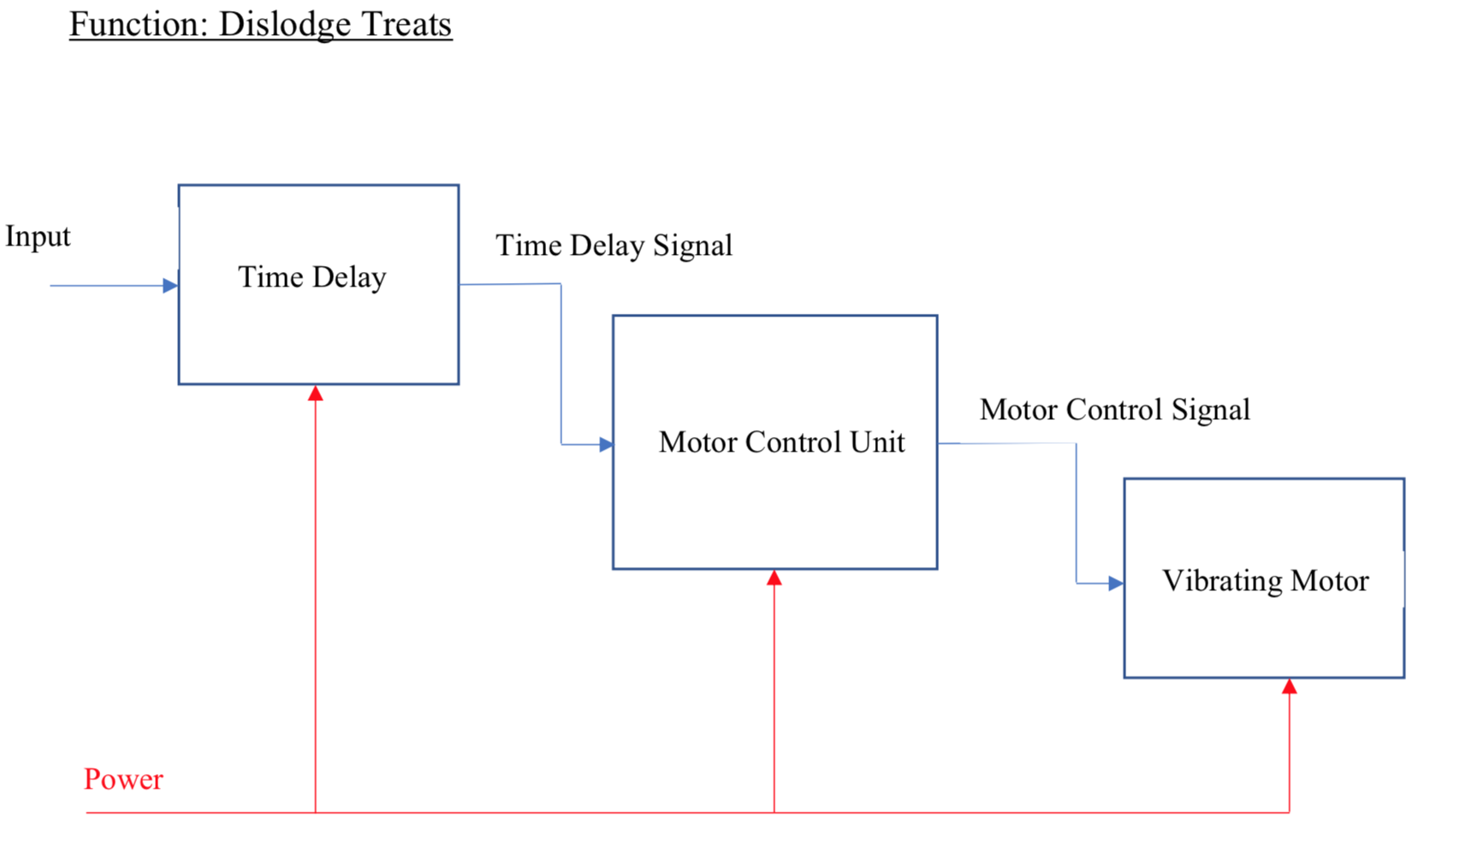

System Architecture

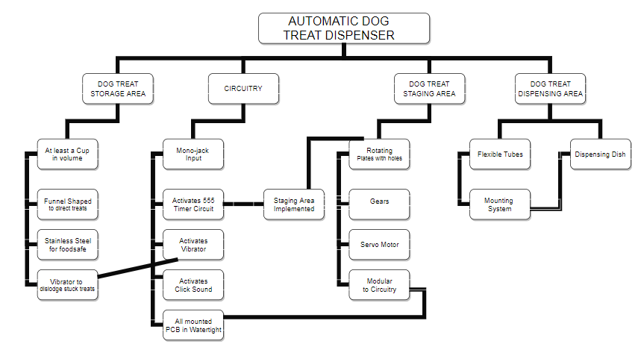

Circuit Design
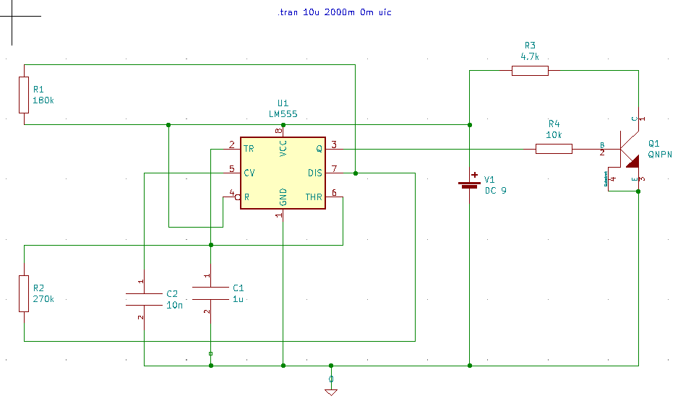

[15]

Circuit Waveform
This is the current that our circuit will be pulling from our 9V supply. Around 50uA * 9V will have us around .5mW
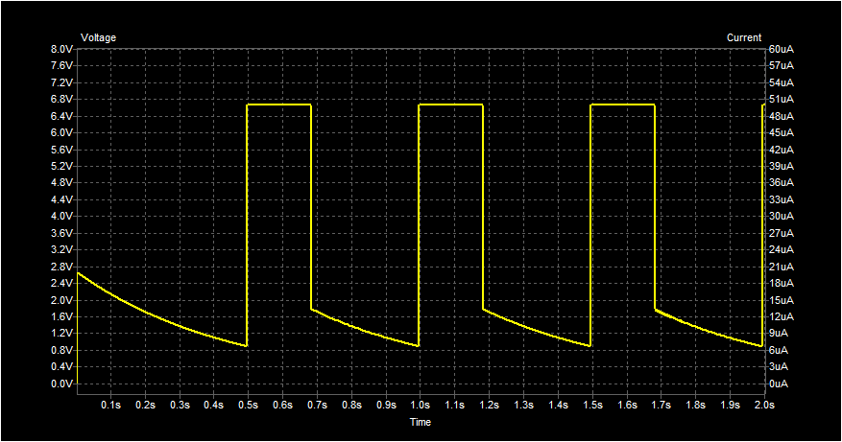
CW 1
This is the direct output from the 555 circuit. Half second pulse to the motor in the circuit which have estimated to be long enough for a half rotation per second.
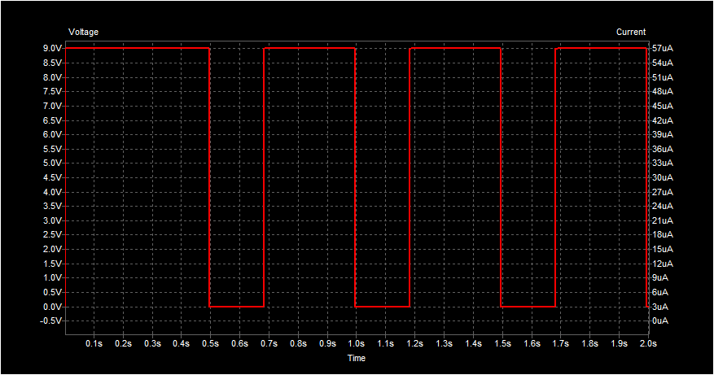
CW 2

Power Requirements
For design 1 the circuit waveform CW1 was calculated to draw .5mW based off the 9V power supply and the 50uA waveform. The motor will leverage is a FS90R which will draw 4W per activation of the motor [28]. It has a maximum stall current of 650mA at 6V which will be at around 4W. The final estimate of each sensor will add around 5W and the clicker activation will also draw around 5W as well. The final estimation of the total power consumption will range from 20-30W total.
For design 2 Raspberry Pi Zero W requires a 1.2A/5V Input which will draw 6W of power for the microcontroller [29]. The team will also leverage additional LEDs and sensors each estimating to be around 5W per addition. The final estimation of the total power consumption will range from 26-36W total.

Preliminary Experimentation Plan
For the project team to properly assess the effectiveness of our design several use cases will be consisting of interactions with the dispenser. They should also anticipate how dogs will react before and after the dispenser operates. The project group also must ensure that the dispenser can vary how many treats it disposes to the dog to ensure that the owner’s interaction with the service dog is reflected properly. Per Dr. Neuber’s information this is important that the original training the owners received can be done with this dispenser without much fault.
Experimental Plan #1 objective will be to have the device dispense any number of treats from the container that holds the treats to the dog bowl mounted onto the wheelchair. The components of this testing case will be a stopwatch, measuring device, and dog treats. Time is important in this first experiment as it tests how long it takes for user input to be relayed and how the service animal reacts to the outputted dog treat. Time from this experiment will be logged for each service animal tested with to ensure that the response received from these animals is not unique. There will be a heavy focus on ensuring that the device is able to dispense a single treat before proceeding into follow up experiments. Both time and observed behavior will determine whether or not the base design would need to go under refactor or not. One thing to note is that jamming in the dispense step may cause the device to malfunction and third party will be ready to provide treats to the dogs in the event the device fails. A scatter plot chart will be used to compare the time observed for a treat to drop and a bar graph will be used to measure the success and failure of the device. Success will be evaluated if consistency across multiple service dogs is reached and the customer who is leveraging the device believes that it was easy to use.
Our second experiment will then focus on variable user input. Our goal with this design is to ensure that a service animal owner can control how many treats the device can output per run. The project team will leverage a measuring device, a stopwatch and dog treat like in experiment one. The testing aspect will be the variable inputs that the owner will perform. The data that the group will collect is whether the device output the correct number of treats, how long did it take to drop the right amount, and whether the dog had responded as it normally would when given that amount. There will be a heavy focus on ensuring that the time between input and output is kept as low as possible while ensuring the proper number of treats matches what the user had requested for. Time will be evaluated on each run to ensure that there are no unique cases based on the service animal or the operator. The device that is being used to input these treats will be independent of the device that is dispensing it as the input device will have the same input connector that is standard for those with mechanical disabilities. A scatter plot chart will be used to compare the time it took for the treat to dispense depending on what the user has inputted. Each input value will have its time compared appropriately while a companion bar graph will demonstrate the successes and failures of the trial runs. If it is determined that the device is constantly outputting the incorrect amount of treats the design team will need to refactor the method of dispensing the treats. Success will be determined when variance on dropped treats reaches zero and the service animal owners user input is properly matching what is being sent to the dispensing device.

Preliminary Project Plan

List of Major Tasks

- Hardware procurement (1 Week)
  - 555 Timers
  - Rotary Device
  - Switches

- Hardware development (3 Weeks)
  - PCB Design
  - PCB Assembly
  - Microcontroller evaluation
  - Power evaluation
  - Storage Container

- System Integration (3 Weeks)
  - System rotary design
  - Variable output functionality
  - Accelerometer functionality

- Wheelchair Integration (1 Week)
  - Placement verification

- Testing (2 Week)
  - Experiment #1
  - Experiment #2

- Data Analysis and Refactor (1 Week)
  - Feedback review and data review

- Reporting (2 Weeks)
  - Initial Progress Report
  - Mid-Flight Report
  - Final Report

- User Acceptance Testing (2 Week)
  - Experiment #1
  - Experiment #2

- Faculty Demos (Part of reporting)
  - Demo #1
  - Demo #2
  - Demo #3

- Customer Demo (Part of reporting phase)
  - Demo #1

Proposed Schedule:

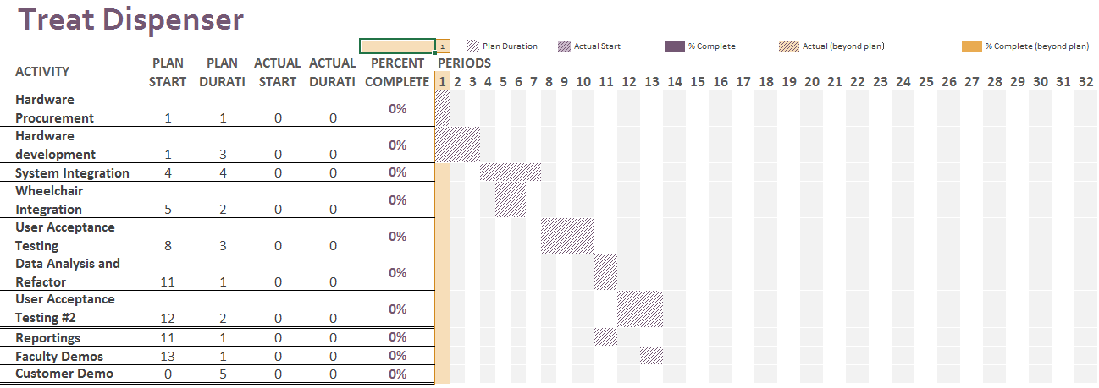
Team Members will meet twice a week with project manager Adam Dost to ensure that the tasks assigned to them will fit inside their weekly schedule and ensure that the team members are able to both succeed in their academics and in their design project. Gage Moore will begin the procurement process and circuit design that the group will use. Zainab Abdullahi, Jachan and Adam Dost will begin researching materials that can act as storage for the dog treats. The entire project group will work together to ensure that the dispenser’s parts are all functional and safe to operate. Robert Wignall will work on the integration piece between the wheel chair and the main dispenser to ensure that the location of dispenser is placed in an area that will ensure the treats that are provided will not impact the person in the wheel chair.

Potential Problems
Since the automatic dog treat dispenser is mostly a mechanical device and is responsible for moving hard dog treats, failures are almost guaranteed. The simple fact that the device is trying to feed treats that are not necessarily uniform through a dispenser that should work consistently is grounds for discussing methods of overcoming issues like jamming or coming apart. As different design types are being discussed, it is apparent that each design will have its own set of problems that will need to be overcome individually as well.
Since the dog treats have the potential of jamming in the dispenser, the dispensing mechanism will need to be solid and able to push through a blockage up to a certain pressure. There is also a potential to add a vibrating motor to the device to rattle the treats loose in the storage compartment and ensure they feed into the dispensing area correctly. This vibrator could be in the center of the dog treat storage compartment to break up any sticky treats as well. The storage compartment will also need to be watertight as the wheelchair may be used in rain. If the treats get wet, they will not feed through the dispenser correctly and can cause other problems down the road, potentially shortening the life of the dispenser.
A major potential problem is that the service dog will not react to the dog treat dispenser. Since the treat is not coming directly from their owner, there needs to be a means to make the device interest the service dog. One potential solution to this would be to add the clicker sound to the treat dispenser that is emitted any time the device is activated. This clicker sound would be the same sound used to train the service dogs so there should be an immediate response. The dispensing/treat dish at the bottom of the device will also need to have some method to draw the dog’s attention to it. The device does not perform its job correctly if the dog is unable to locate the treats easily. This dish should also be in the view of the wheelchair user so that they can confirm the treats were dispensed and that their service dog was able to retrieve the treats.
Another potential problem is to have the device easily wheelchair mountable. The device will need to be small to add flexibility of mounting locations and extendable, flexible tubes will need to be used so the dish can be mounted wherever on the wheelchair independent of the main device location. The device will also need to be robust and shock resistant so it does not fall apart while driving around in the wheelchair, which can have jerk-like movements.
As mentioned before, the entire dog treat track must be food safe. There are multiple sections to the device, so the introduction of connections between parts and having gaps can create unsafe areas for germs and bacteria to grow and develop. Thus, the device needs to be able to come apart fully for complete cleaning. It is a bonus if the dog treat track can be removed from the electronics and made dishwasher safe.
With the treat dispenser mounted to the wheelchair, and being rechargeable battery powered, there is a potential for the device to lose power and stop working throughout the user’s day. The device should either have indications of rechargeable battery level that can be checked prior to each day’s use, and/or have a rechargeable battery. There could also be a warning sound that emits when the rechargeable battery is getting low and replacement or recharging is recommended. This is so the user does not falsely assume they will be able to start working on a new task with their service dog thinking they will be able to treat their dog all along the way. If they start and the device stops working partway through, there could be negative consequences of the training.
In the stopper-style design, a blade is introduced to help prevent jams and too many treats being dispensed. This also introduces a safety hazard if the blade comes loose. The blade will need to be firmly attached and easily removable so it is not flung on accident and can be cleaned.
The gumball and Ferris-wheel style designs both introduce spinning wheels/discs, which can easily be jammed if the axis gets filled with gunk or food particles start to build up along the outside of the discs causing them to scrape against their enclosure. The user will need to be able to open up this section and clean out any jams.
Since there may be some complexities to the design and pieces should come apart for cleaning, there is a potential that the user will not be able to put the dispenser back together. For this reason, the device should be somewhat modular with clear indications on what connects to where. An assembly diagram can also be provided and stuck to the device somewhere for easy reference.
The treat dispenser needs to help strengthen the bond between the disabled person in the wheelchair and the service dog and any problems that might get in the way of that need to be overcome. The device should be as simple to use as possible to make the user’s life easier at the end of the day, not complicate anything.

Weekly Meetings
This form must be completed by the PM during each team meeting. Filled forms must be kept by the PM and submitted to the FS/CC upon request.

Project Title: Treat Dispenser for Service Dogs of Virginia Meeting Date: 09/13

Team members present: Adam Dost, Gage Moore, Jachan Shrestha, Robert Wignall, Zainab Abdullahi
Team members absent: n/a

Task progress report for the last week effort:

Line# | Task description | Team member  assigned | Progress  0%-100% | Delivery proof
1 | Meet with stakeholder Dr. Neuber and discuss previous attempts to solve current problem | All | 100% | SStakeholder Dr.Neuber

Task allocation for the next week:

Line# | Task description | Team member  assigned
1 | (Proposal) Executive Summary creation | Gage M.
2 | (Proposal) Problem statements | Zainab A.
3 | (Proposal) Approach – Including a problem | Jachan S.
4 | (Proposal) Prelim list | Adam D.
5 | (Proposal) Preliminary Design | Robert W.

PM name: Adam Dost

ECE-492 Weekly Task Allocation/Delivery

This form must be completed by the PM during each team meeting. Filled forms must be kept by the PM and submitted to the FS/CC upon request.

Project Title: Treat Dispenser Meeting Date: 09-19

Team members present: Robby, Adam, Zainab, Jachan, Gage
Team members absent: NA

Task progress report for the last week effort:

Line# | Task description | Team member  assigned | Progress  0%-100% | Delivery proof
1 | (Proposal) Executive Summary creation | Gage M. | 100% | Submitted via Slack
2 | (Proposal) Problem statements | Zainab A. | 70% | Verified via Slack
3 | (Proposal) Approach | Jachan S. | 70% | Verified in person
4 | (Proposal) Prelim list | Adam D | 100% | Uploaded to slack
5 | (Proposal) Preliminary Design | Robert W. | 70% | WIP, Verified in Person

Line# | Task description | Team member  assigned
1 | Problem statements (cont) | Zainab A.
2 | Approach (cont) | Jachan S.
3 | Preliminary Design (cont) | Robert W.
4 | Proposal – Master Document Creation | Adam D.
5 | Functional Diagram | Gage Moore

PM name: Adam Dost

ECE-492 Weekly Task Allocation/Delivery

This form must be completed by the PM during each team meeting. Filled forms must be kept by the PM and submitted to the FS/CC upon request.

Project Title: Treat Dispenser Meeting Date: 10-03

Team members present: Robby, Adam, Zainab, Jachan, Gage
Team members absent: NA

Task progress report for the last week effort:

Line# | Task description | Team member  assigned | Progress  0%-100% | Delivery proof
1 | Problem statements (cont) | Zainab A. | 100% | Uploaded to Slack
2 | Approach (cont) | Jachan S. | 80% | Uploaded to Slack
3 | Preliminary Design (cont) | Robert W. | 80% | Uploaded to Slack
4 | Proposal – Master Document Creation | Adam D. | 100% | Google Doc created
5 | Functional Diagram | Gage Moore | 100% | Functional Diagram

Line# | Task description | Team member  assigned
1 | Approach (cont) | Jachan S., Zainabi
2 | Preliminary Design (cont) | Robert W.
3 | Expected Roles | Adam D.
4 | Circuit Design | Gage Moore

PM name: Adam Dost

References
- “Disability Impacts All of Us Infographic | CDC.” Centers for Disease Control and Prevention, Centers for Disease Control and Prevention, www.cdc.gov/ncbddd/disabilityandhealth/infographic-disability-impacts-all.html.

- “Physical Assistance Dogs.” Service Dogs of Virginia, Service Dogs of Virginia, https://www.servicedogsva.org/learn/programs/physical_assistance_dogs/.

- Hall, Sophie S et al. “A survey of the impact of owning a service dog on quality of life for individuals with physical and hearing disability: a pilot study.” Health and quality of life outcomes vol. 15,1 59. 29 Mar. 2017, doi:10.1186/s12955-017-0640-x

- Maclean, “Wheelchair-Mounted Dog Treat Dispenser,” Wheelchair-Mounted Dog Treat Dispenser. [Online]. Available: https://www.makersmakingchange.com/project/wheelchair-mounted-dog-treat-dispenser/.

- J. Rutledge, “Animal Food and Treat Dispenser,” 6,988,464 B1, 24-Jan-2006.

- C. Brown and S. Giddens, “Treat Dispenser,” US 2003/0057228A1, 27-Mar-2003.

- D. Franche, “Dog Food Dispenser,” 4,176,767, 04-Dec-1979.

- F. Depenthal and K. Swartz, “Automatic Feeding Device,” 3,782,332, 01-Jan-1974.

- M. Johnson, “Pet Feeder System For a Handicapped Pet Owner,” 8,479,686 B2, 09-Jul-2013.

- N. Lewis and R. Brace, “Pet Feeding System And Method Using Same,” 6,349,671 B1, 26-Feb-2002.

- D. Robinson and S. Robinson, “Automatic Animal Feeder,” 4,671,210, 09-Jun-1987.

- W. Blaydes and C. Britton, “Dispensing Machine,” 1,928,556, 26-Sep-1933.

- Y. Wang, “Treat Dispenser,” 2013/0233246A1, 12-Sep-2013.
- “3D Printer Material Cost – The Real Cost of 3D Printing Materials,” All3DP, 10-Aug-2019. [Online]. Available: https://all3dp.com/2/3d-printer-material-cost-the-real-cost-of-3d-printing-materials/. [Accessed: 22-Oct-2019].

- “Plastic Enclosures & Boxes for the Electronics Industry | Polycase.” [Online]. Available: https://www.polycase.com/. [Accessed: 22-Oct-2019].

- “Project Boxes,” All Electronics Corp. [Online]. Available: https://www.allelectronics.com/category/490/project-boxes/1.html. [Accessed: 22-Oct-2019].

- “Teach, Learn, and Make with Raspberry Pi – Raspberry Pi.” [Online]. Available: https://www.raspberrypi.org. [Accessed: 22-Oct-2019].

- A. Helen, “Choosing the Right Motor for Your Project – DC vs Stepper vs Servo Motors.” [Accessed: 22-Oct-2019].

- “How to Waterproof Wood,” wikiHow. [Online]. Available: https://www.wikihow.com/Waterproof-Wood. [Accessed: 22-Oct-2019].
- “Drive Servos With a 555 Timer IC.” Edited by Gefetters :Instructables, Instructables, Instructables, 20 Oct. 2017, www.instructables.com/id/Drive-Servos-with-a-555-timer-IC/.

- “Automatic Turn OFF Power Circuit.” ElectroSchematics.com, 7 Mar. 2013, www.electroschematics.com/automatic-turn-off-power/.

- Jezernik, K., and M. Rodic. “High Precision Motion Control of Servo Drives.” IEEE Transactions on Industrial Electronics, vol. 56, no. 10, 2009, pp. 3810–3816., doi:10.1109/tie.2009.2020709.

- Mechatronics, How To. “How To Make a PWM DC Motor Speed Controller Using the 555 Timer IC.” YouTube, YouTube, 15 Feb. 2018, www.youtube.com/watch?v=R1jP2mvG0Wk.

- “Delay Before Turn Off Circuit with a 555 Timer.” How to Build a Delay Before Turn Off Circuit with a 555 Timer, www.learningaboutelectronics.com/Articles/555-timer-delay-before-turn-off-circuit.php.

- Swagatam. “Simple Delay Timer Circuits Explained.” Homemade Circuit Projects, 30 Sept. 2019, www.homemade-circuits.com/simple-delay-timer-circuits-explained/.

- xoftc. “555 Servo Control Using 2 Buttons.” YouTube, YouTube, 7 Oct. 2015, www.youtube.com/watch?v=jm9FFREzeI8.

- GEN, POWER. “Relay OFF Time Delay Timer by Using NPN Transistor and Capacitor.” YouTube, YouTube, 2 Mar. 2018, www.youtube.com/watch?v=ZHsUC4fYw8c

- “Continuous Rotation Micro Servo [FS90R] ID: 2442 - $7.50 : Adafruit Industries, Unique & fun DIY electronics and kits.” [Online]. Available: https://www.adafruit.com/product/2442?gclid=Cj0KCQjw0brtBRDOARIsANMDykZM_o-SLs9Gf7AtLB_AFkEGiJs20nIDk34L36z1GMfcGGiof2Btzl0aAvcYEALw_wcB. [Accessed: 22-Oct-2019].

- “FAQs - Raspberry Pi Documentation.” [Online]. Available: https://www.raspberrypi.org/documentation/faqs/#pi-power. [Accessed: 22-Oct-2019].

