Power Testing
A key feature of the wheelchair-mounted treat dispenser is that it is powered separately from the automatic wheelchair. Thus, a battery pack must be used. The power requirements for the wheelchair-mounted treat dispenser’s battery pack is put together from the following as designated in the design document:
Functional Requirement
- The device will hold up to at least one cup of treats at a time in order to allow for treats to be provided to the service animal throughout at least one full day
Operational Requirement
- The device will be integrated seamlessly to a wheelchair without being too bulky.
Technology
- Shall use rechargeable batteries to keep the economic impact minimal.
From this, we pull the following power requirements for the battery pack to be:
- Must be rechargeable.
- Must run for at least 18 hours on a single charge.
  - 18 hours represents a full day from the time a user would wake up to the time they would go to sleep.
  - Within 18 hours, an average of 50 uses will be necessary.
- Must be small and light enough to interfere with wheelchair usage.
After some initial testing of the circuits using an ammeter, the following power draws were found:

Circuit Load | Min. (Watts) | Max. (Watts)
Treat Level Sensor (Yellow LED On, Blue LED On) | 0.39 | 0.41
Treat Level Sensor (Yellow LED On, Blue LED Off) | 0.375 | 0.395
Treat Level Sensor (Yellow LED Off, Blue LED On) | 0.37 | 0.38
Treat Level Sensor Off (Idle Circuit) | 0.3 | 0.325
Servomotor Activation (LEDs On) | 1.125 | 2.445
Clicker Sound Module with Sensor (LEDs On) | 0.79 | 1.29
Clicker Sound Module (LEDs On) | 0.89 | 0.935
Clicker Sound Module Sensor (LEDs On) | 0.625 | 0.645
Vibrating Motor (LEDs On) | 0.65 | 0.695

Table 1: Circuit Load Power Draws
Since all of the modules operate separately with the treat level sensor, the worst case scenario is that the treat level sensor has both the yellow and blue LED on indicating that the treat storage compartment is full while the Servomotor is being activated. This load 2.445 Watts.
Thus, with a 12 VDC battery pack output, the max output current needed is 2.445 W / 12 V = 0.204 A. Since batteries only have a certain efficiency (around 95%), there should be a safety factor applied as well as a slight conservative threshold. Thus, multiplying 0.204 by 1. 2 gives a 20% safety factor and means the battery pack will need to be able to supply a current of up to 0.245 A. Round this up to 0.5 A at 12 VDC to ensure the battery will be strong enough to power the dispenser.
Below is the decision matrix on which type of battery would be best for the device. As can be seen, there were two battery types that seemed to be the best fit. These are Nickel-Metal Hydride and Lithium Ion batteries.

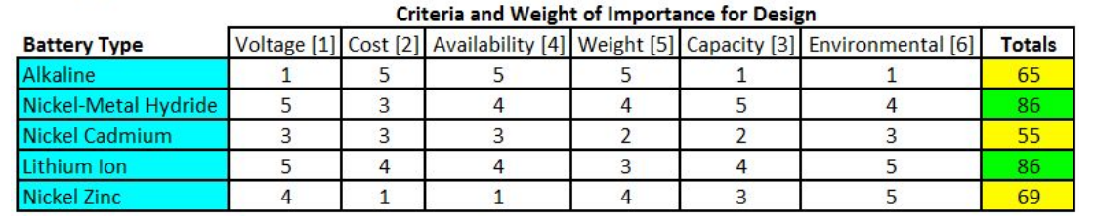
Table 2: Battery Type Decision Matrix

Originally, it was determined that the design would use Nickel-Metal Hydride batteries for the 555 Timer Circuit solution and the Lithium Ion batteries for the Microcontroller solution. After some research, a Lithium Ion battery pack was found that would work for both solutions. The specifications and data sheet on this battery can be found in Appendix A. The battery pack is unique for this project in that it has a 5V USB output that can be used to power the Raspberry Pi W Zero and a 12 VDC output that can be used to power the 555 timer circuit. The device is easy to use, should power the circuits without issue, and has a fairly quick charge time (~12 hours for a full charge based on specifications).
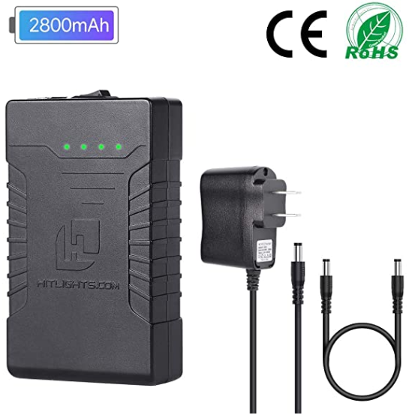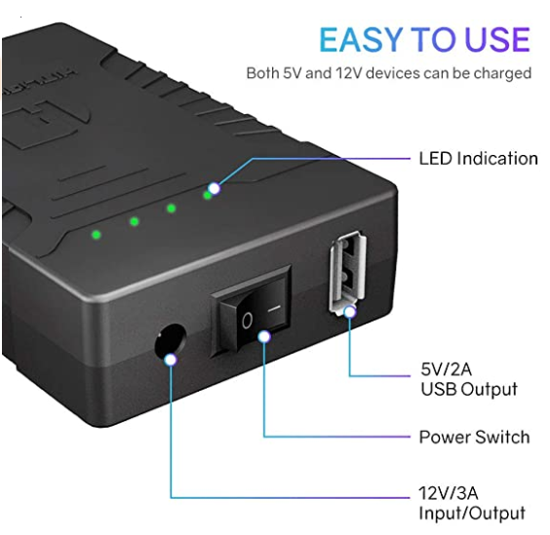
This battery has sufficient output power (3A at 12 VDC) to drive the circuitry as shown with the power draws of the different modules as shown above. The battery is a 2800 mAh unit. To see if this will be enough to power the treat dispenser based on the power requirements as listed above, a profile of how the device will be used needs to be created. This will be as follows:
Within 18 hours, the device will be activated at least 50 times. The treat dispenser will be assumed to be full of treats for the duration of the 18 hours. Vibrating motor will be assumed to be run for an average of 1 minute a day. The vibrating motor does not need to be activated long to perform its task of dislodging a stuck treat. 1 minute would coincide with around 30 activations.
Thus, the modules will be active for the amount of times as shown in Table 3 below.

Circuit Load | Device Usage Profile Times
Idle Current (Yellow LED On, Blue LED On) | 18 hours
Idle Current (Yellow LED On, Blue LED Off) | 0
Idle Current (Yellow LED Off, Blue LED On) | 0
Idle Current (Yellow LED Off, Blue LED Off) | 0
Servo Motor Activation | 100 seconds
Clicker Sound Module with Sensor | 100 seconds
Clicker Sound Module | 0
Clicker Sound Module Sensor | 0
Vibrating Motor | 60 seconds

Table 3: Device Module Run Times for Power Profile

The servomotor and clicker module were estimated to be active for around 100 seconds since they are active for around 2 seconds per activation (50 activations x 2 = 100). From this, the average power draw of the device over 18 hours can be given by:
$$Average Power Draw=\frac{\left[\left(0.41*18*60*60\right)+\left(2.445*100\right)+\left(1.29*100\right)+\left(0.695*60\right)\right]}{18*60*60}$$
$$=0.416 Watts=0.0347 Amps at 12 VDC$$
Again, it is good to be conservative. Estimating the Average Power Draw at 0.1 Amps at 12 VDC will be used to provide plenty of overhead. According to the specifications in Appendix A, the runtime of the battery can be found by dividing 2.8 Ah by the Average Power Draw of 0.1 Amps.
$$Estimated Run Time=\frac{2.8}{0.1}=28 hours$$
This battery pack was purchased and testing was performed to ensure it would measure up to these estimations. The battery was tested twice from full charge until it completely died.
Test 1:
The battery was first depleted according to the following testing parameters.
Time | Activations | Treat Dislodging  (Vibrating Motor Active Time) | Battery Level (Given by LEDs)
8:30 AM | 3 |  | 4 LEDs
1:00 PM | 3 | 10 | 3 LEDs
9:00 PM | 30 | 10 | 2 LEDs
10:00 PM | 30 | 10 | 2 LEDs
11:00 PM | 30 | 10 | 1 Solid 1 Flashing LED
1:20 AM | 10 | 10 | 1 Solid 1 Flashing LED
8:15 AM | 5 | 10 | 1 Solid 1 Flashing LED
9:00 AM | 20 |  | 1 Solid 1 Flashing LED
10:20 AM | 20 |  | 1 Solid 1 Flashing LED
11:20 AM | 5 |  | 1 LED
1:01 | 5 |  | 1 LED
2:00 | BATTERY DEAD |  | 0 LEDs

Then, the battery was recharged to see if the 12 hour charge time was accurate. This timing is shown below.
Time | Battery Level
6:00 PM | Start
6:37 PM | 1 LED
8:00 PM | 2 LEDs
9:30 PM | 3 LEDs
6:00 AM | Fully Charged
Based on the above test, the device was activated 161 times, which is 3 times more than necessary on one charge. The battery lasted well over 18 hours dying after staying active for around 29.5 hours.
Test 2:
The battery was again depleted according to the following parameters.
Time | Activations | Treat Dislodging (Vibrating Motor Active time) | Battery Level (Given by LEDs)
8:30 AM | 10 |  | 4 LEDs
11:35 AM | 5 |  | 3 LEDs
1:00 PM | 20 | 30 | 2 LEDs
2:00 PM | 20 |  | 2 LEDs
7:35 PM | 20 | 30 | 1 Solid 1 Flashing LED
8:00 PM | 10 | 20 | 1 Solid 1 Flashing LED
9:00 PM | 20 |  | 1 Solid 1 Flashing LED
10:30 PM | 20 | 60 | 1 Solid 1 Flashing LED
8:30 AM | 20 |  | 1 Solid 1 Flashing LED
11:00 AM | 20 |  | 1 LED
1:00 PM | BATTERY DEAD |  | 0 LEDs

Again, the battery was recharged to see how long it would take as shown below.
Time | Battery Level
2:00 PM | Start
2:30 PM | 1 LED
3:00 PM | 2 LEDs
6:46 PM | 3 LEDs
8:30 PM | 4 LEDs

Based on the above test, the device was activated 165 times and died after around 28.5 hours. This time, however, the battery seemed to be fully charged after only 6.5 hours.
It can also be seen that, since a 75% charge will allow for over 50 activations and over 24 hours of run time, only a 4.5 hour charge is really needed for a user to get through an 18 hour day. Thus, the battery meets all the requirements as listed in the beginning of the document.
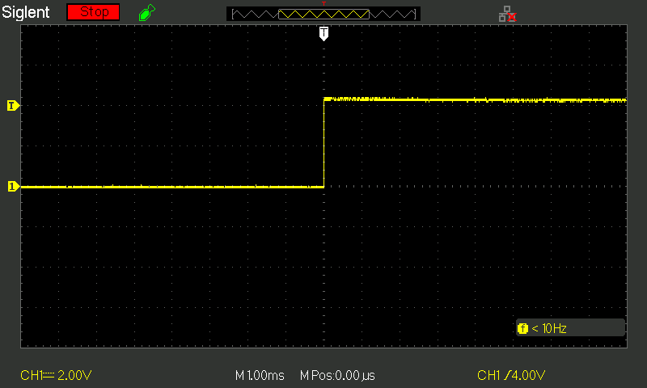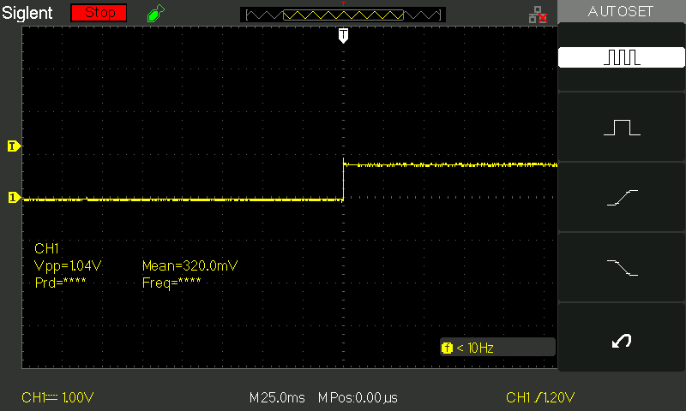
Clicker Module Voltage Change During Activation
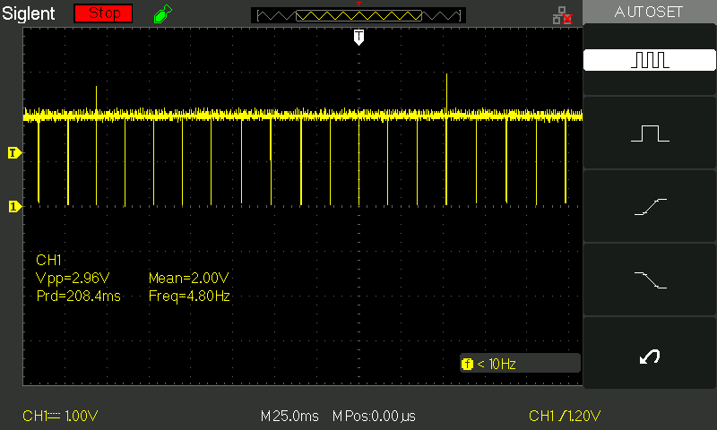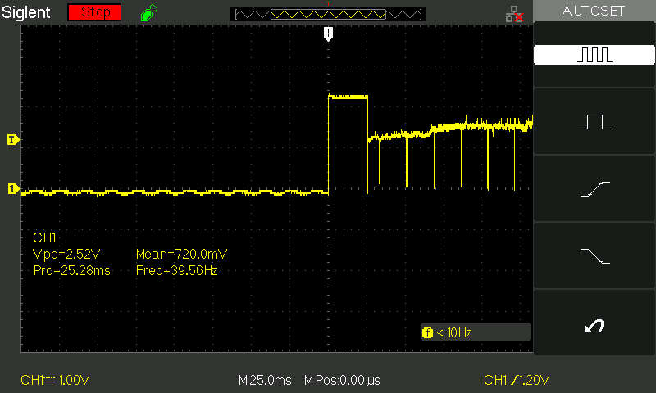
Servomotor Voltage Draw (555 Timer Output During Activation)

Appendix A
Our Rechargeable Lithium-Ion Batteries are specifically designed to power our flexible LED Light Strips rolls or Light Bars and are a small, convenient, and portable solution to your on-the-go low voltage lighting needs.
they're particularly well suited for lighting up costumes, bicycles or anything else that needs to be lit up while 'on the move'. They include everything you need to get your lights mobile, including the battery itself, a cable and a charger to hook straight into your wall outlet, and are also popular with manufacturers who need a compact and reliable 12-volt power source for their products or anyone looking to replace a wired power supply, transformer, or adapter.
They now come with a 5V USB output port for charging your cell phones, tablets, and other electronic devices
Charging Instructions :
- Plug AC Charger into the electric outlet
- Connect your charger to your battery with the included connector cable
- Set the switch on the Battery to the 'On' position
- Charge time to full capacity: Approximately 12 hours
Specifications:
- Charger Input: 110V-240V AC (Standard North American NEMA 1 plug)
- Battery Output 1:12V DC / 30 Watts (2.5 Amps) maximum - Output cable with 5.5 x 2.1 mm DC jack
- Battery Output 2: 5V DC USB Plug
- Dimensions : 23 x 100 x 60 mm (15/16 x 3-15/16 x 2-3/8 inches)
To calculate how long your battery will last, divide the capacity (eg 2800 mAh or 2.8 aH) by the current draw (in amps, or your wattage divided by 12), for the result in hours.
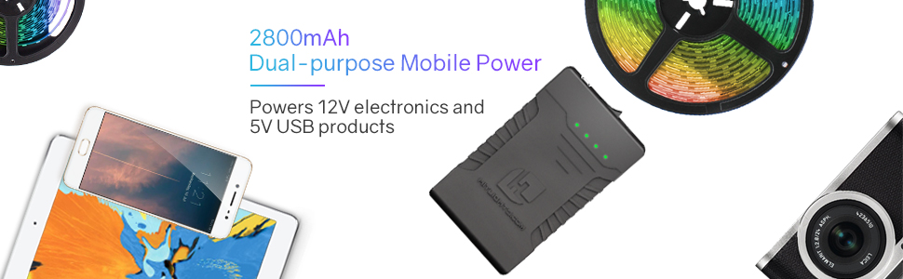
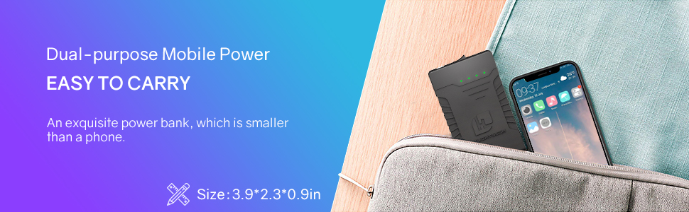

Multi Usage
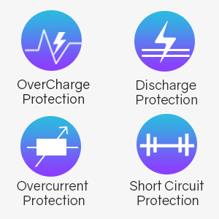 | 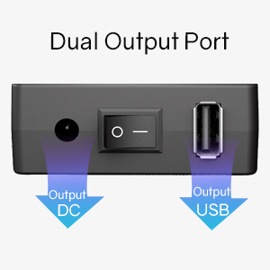 | 